SUB QUERY:
Question 1:
Write an SQL query using a subquery to display the details of employees whose salary is greater than the average salary of all employees.

use nov12;
SELECT * FROM Worker WHERE SALARY > (SELECT AVG(SALARY) FROM Worker);

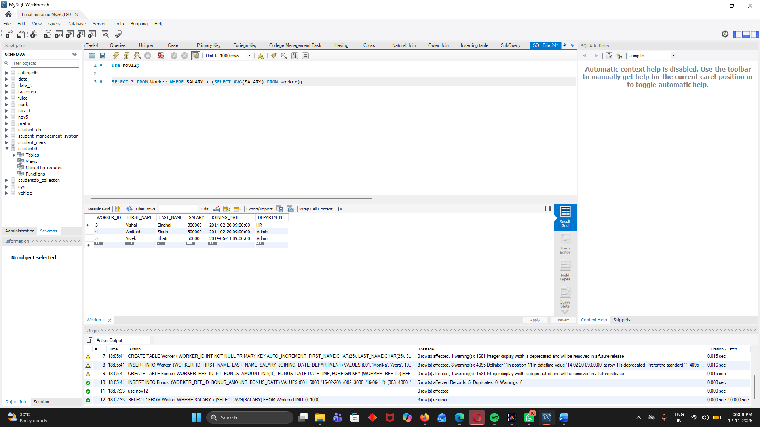

Question 2:
Write an SQL query using a subquery to display the first name, last name, and salary of employees who belong to the same department as the employee named Monika.

SELECT FIRST_NAME, LAST_NAME, SALARY FROM Worker WHERE DEPARTMENT = (
SELECT DEPARTMENT
FROM Worker
WHERE FIRST_NAME = 'Monika'
);

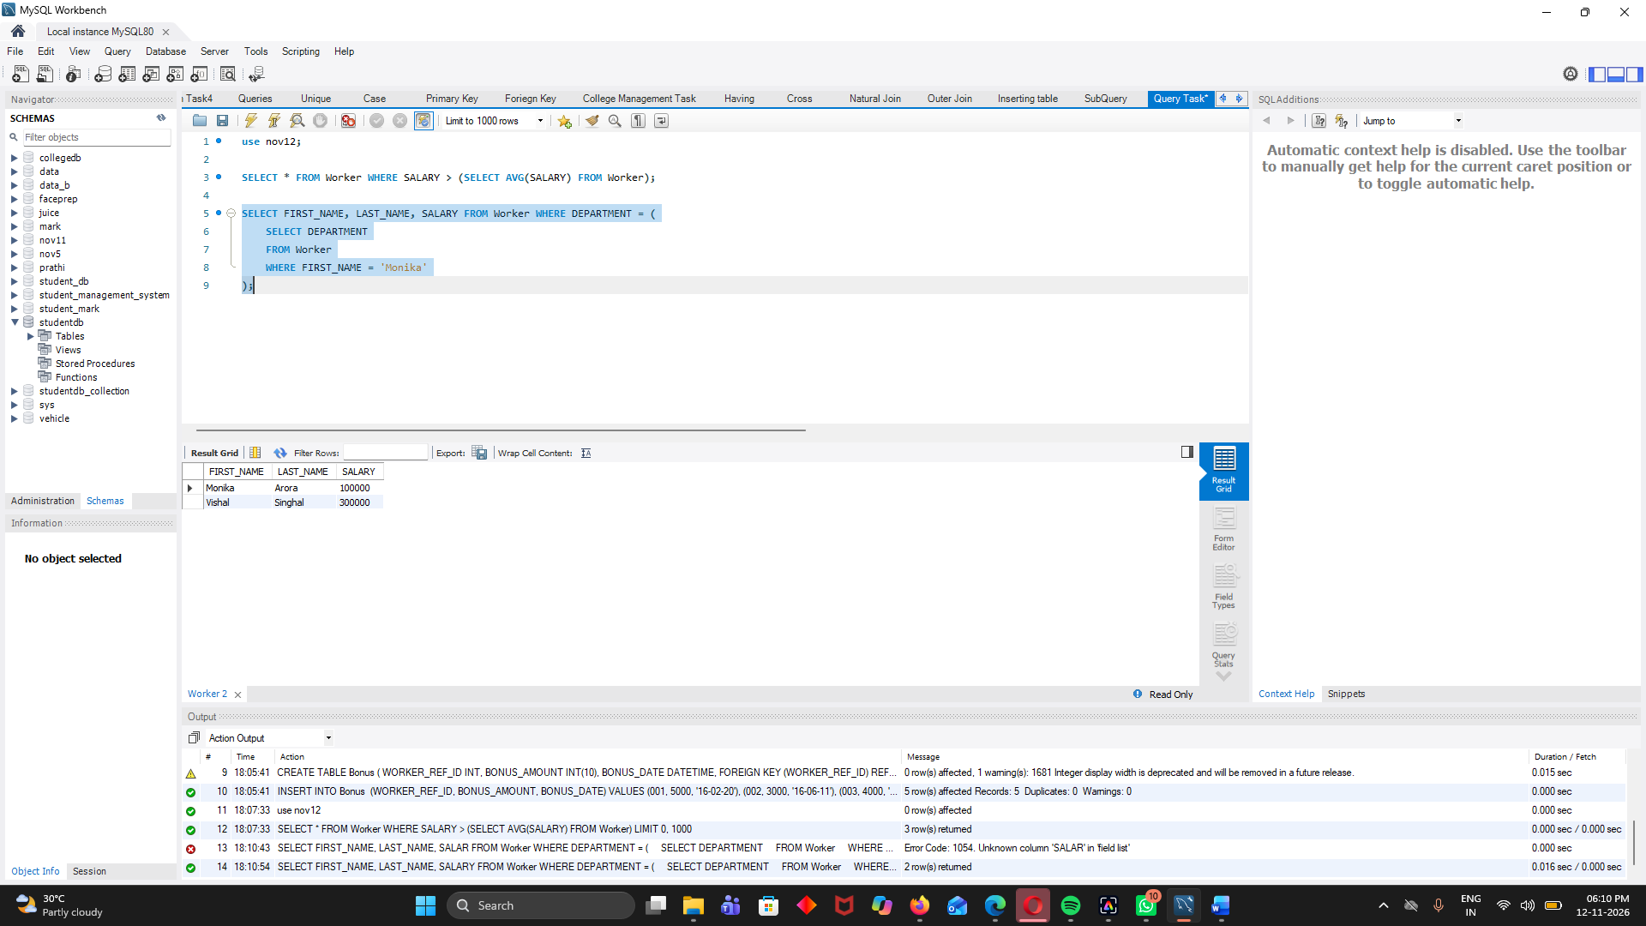

Question 3:
Write an SQL query using a subquery to display the first name, last name, and department of employees who have received at least one bonus.
SELECT FIRST_NAME, LAST_NAME, DEPARTMENT FROM Worker WHERE WORKER_ID IN (
SELECT WORKER_REF_ID
FROM Bonus
);

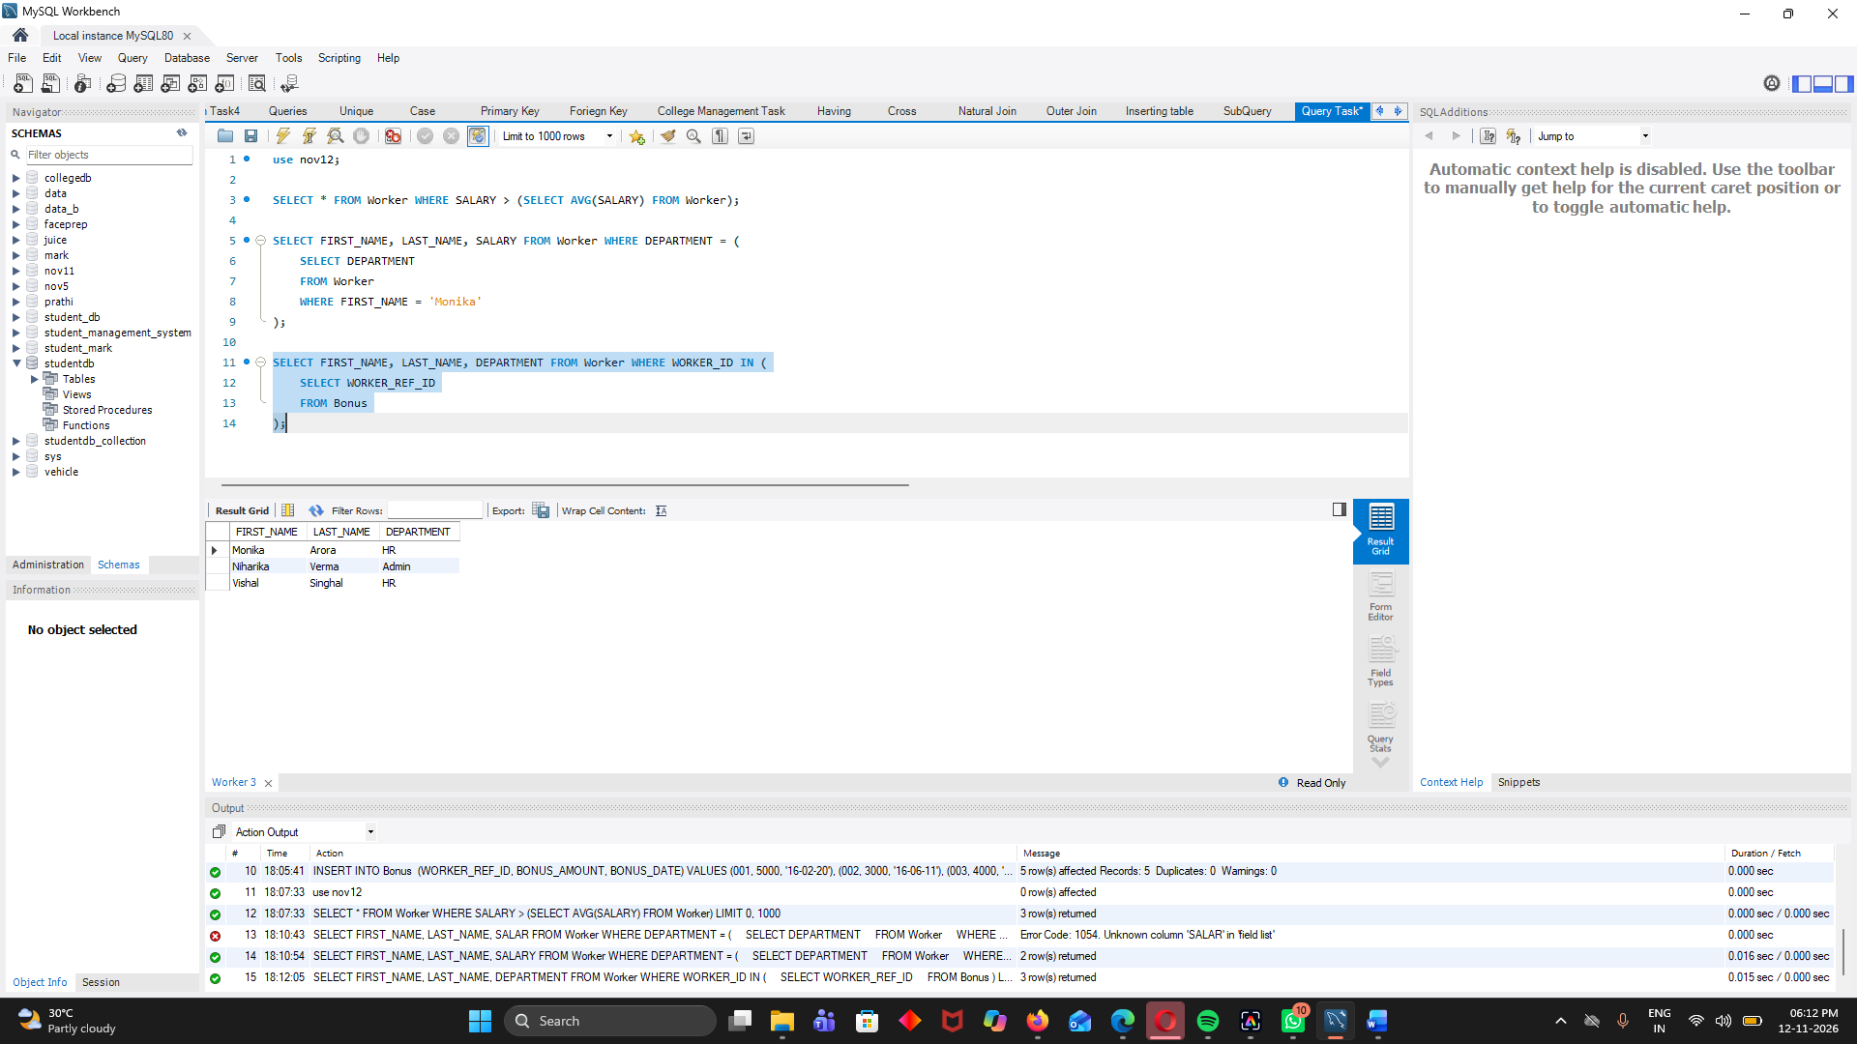

Test :
Inserting code:

create database Test;
use test;
CREATE TABLE Worker (
WORKER_ID INT NOT NULL PRIMARY KEY AUTO_INCREMENT,
FIRST_NAME CHAR(25),
LAST_NAME CHAR(25),
SALARY INT(15),
JOINING_DATE DATETIME,
DEPARTMENT CHAR(25)
);

INSERT INTO Worker
(WORKER_ID, FIRST_NAME, LAST_NAME, SALARY, JOINING_DATE, DEPARTMENT) VALUES
(001, 'Monika', 'Arora', 100000, '14-02-20 09.00.00', 'HR'),
(002, 'Niharika', 'Verma', 80000, '14-06-11 09.00.00', 'Admin'),
(003, 'Vishal', 'Singhal', 300000, '14-02-20 09.00.00', 'HR'),
(004, 'Amitabh', 'Singh', 500000, '14-02-20 09.00.00', 'Admin'),
(005, 'Vivek', 'Bhati', 500000, '14-06-11 09.00.00', 'Admin'),
(006, 'Vipul', 'Diwan', 200000, '14-06-11 09.00.00', 'Account'),
(007, 'Satish', 'Kumar', 75000, '14-01-20 09.00.00', 'Account'),
(008, 'Geetika', 'Chauhan', 90000, '14-04-11 09.00.00', 'Admin');

CREATE TABLE Bonus (
WORKER_REF_ID INT,
BONUS_AMOUNT INT(10),
BONUS_DATE DATETIME,
FOREIGN KEY (WORKER_REF_ID)
REFERENCES Worker(WORKER_ID)
ON DELETE CASCADE
);

INSERT INTO Bonus
(WORKER_REF_ID, BONUS_AMOUNT, BONUS_DATE) VALUES
(001, 5000, '16-02-20'),
(002, 3000, '16-06-11'),
(003, 4000, '16-02-20'),
(001, 4500, '16-02-20'),
(002, 3500, '16-06-11');
CREATE TABLE Title (
WORKER_REF_ID INT,
WORKER_TITLE CHAR(25),
AFFECTED_FROM DATETIME,
FOREIGN KEY (WORKER_REF_ID)
REFERENCES Worker(WORKER_ID)
ON DELETE CASCADE
);

INSERT INTO Title
(WORKER_REF_ID, WORKER_TITLE, AFFECTED_FROM) VALUES
(001, 'Manager', '2016-02-20 00:00:00'),
(002, 'Executive', '2016-06-11 00:00:00'),
(008, 'Executive', '2016-06-11 00:00:00'),
(005, 'Manager', '2016-06-11 00:00:00'),
(004, 'Asst. Manager', '2016-06-11 00:00:00'),
(007, 'Executive', '2016-06-11 00:00:00'),
(006, 'Lead', '2016-06-11 00:00:00'),
(003, 'Lead', '2016-06-11 00:00:00');
1. Write an SQL query to display the details of employees who belong to the HR department.
SELECT * FROM Worker WHERE DEPARTMENT = 'HR';
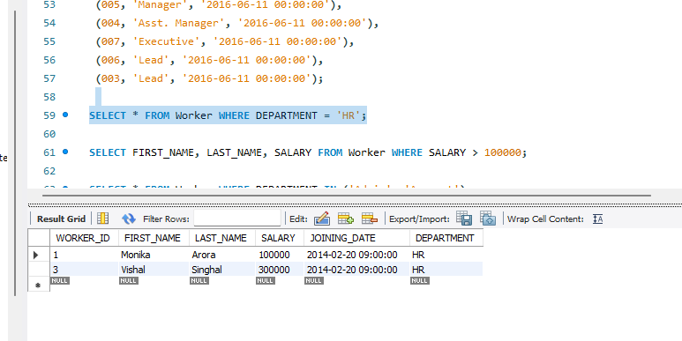
2. Write an SQL query to display the first name, last name, and salary of employees whose salary is greater than 100000.
SELECT FIRST_NAME, LAST_NAME, SALARY FROM Worker WHERE SALARY > 100000;
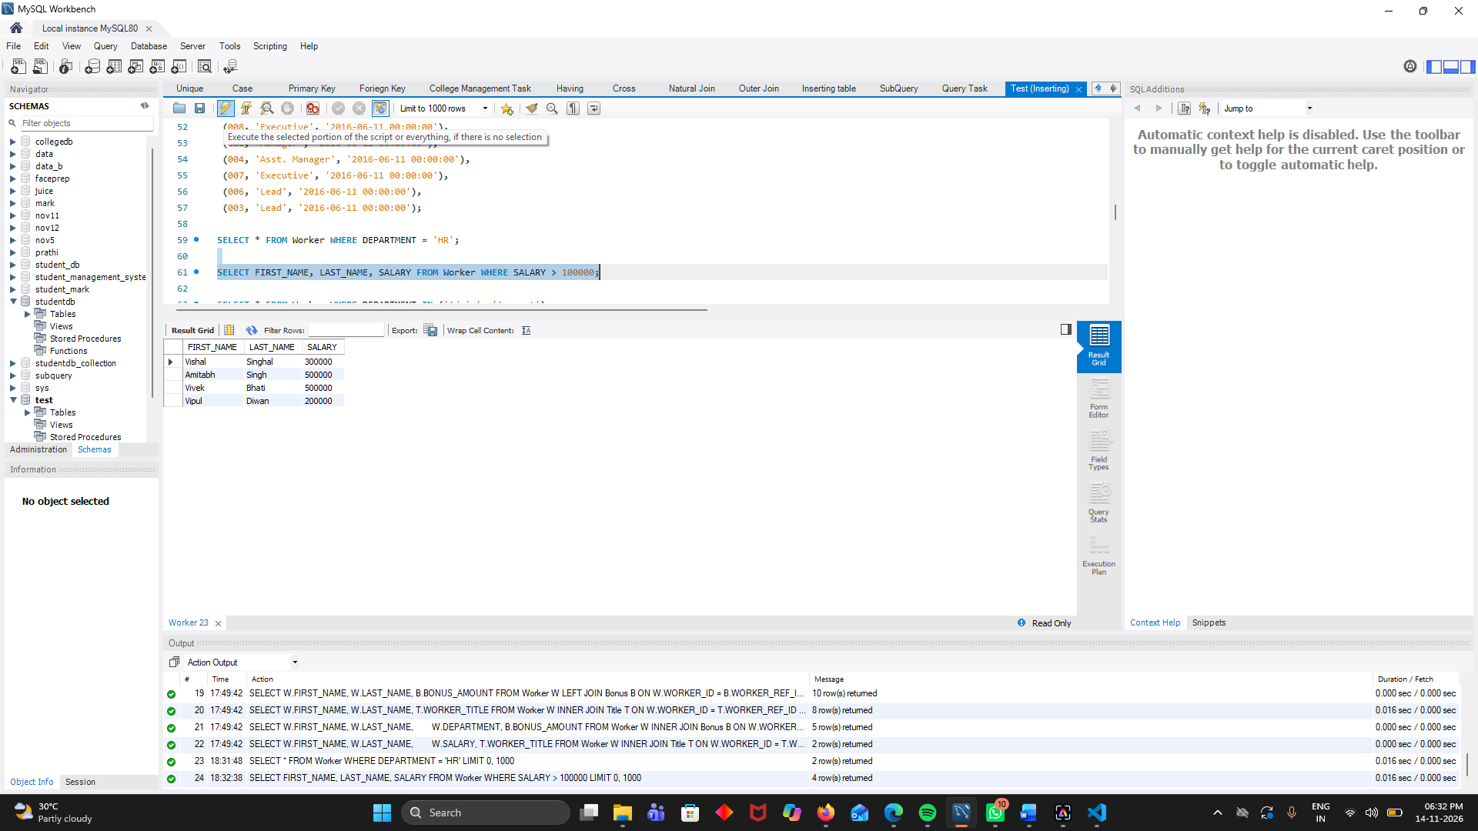

3. Write an SQL query to display employees whose department is either Admin or Account.
SELECT * FROM Worker WHERE DEPARTMENT IN ('Admin', 'Account');
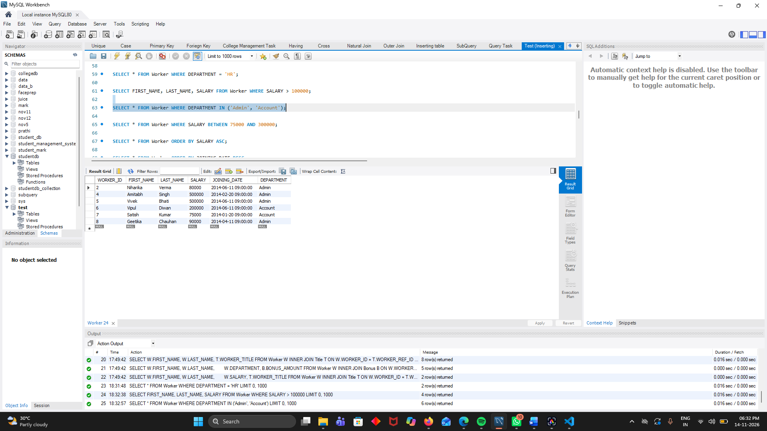

4. Write an SQL query to display employees whose salary is between 75000 and 300000.
SELECT * FROM Worker WHERE SALARY BETWEEN 75000 AND 300000;
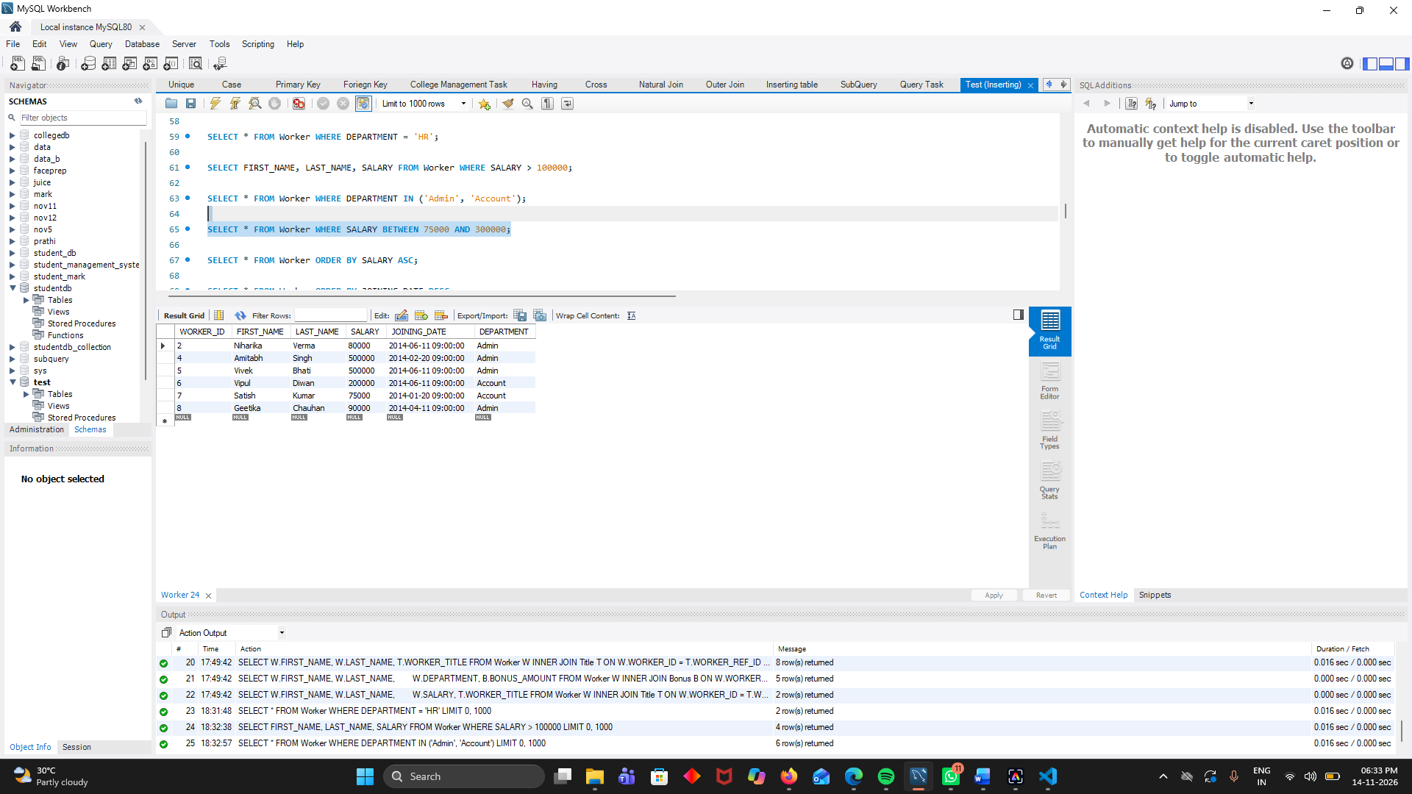
5. Write an SQL query to display all employee details in ascending order of their salary.
SELECT * FROM Worker ORDER BY SALARY ASC;
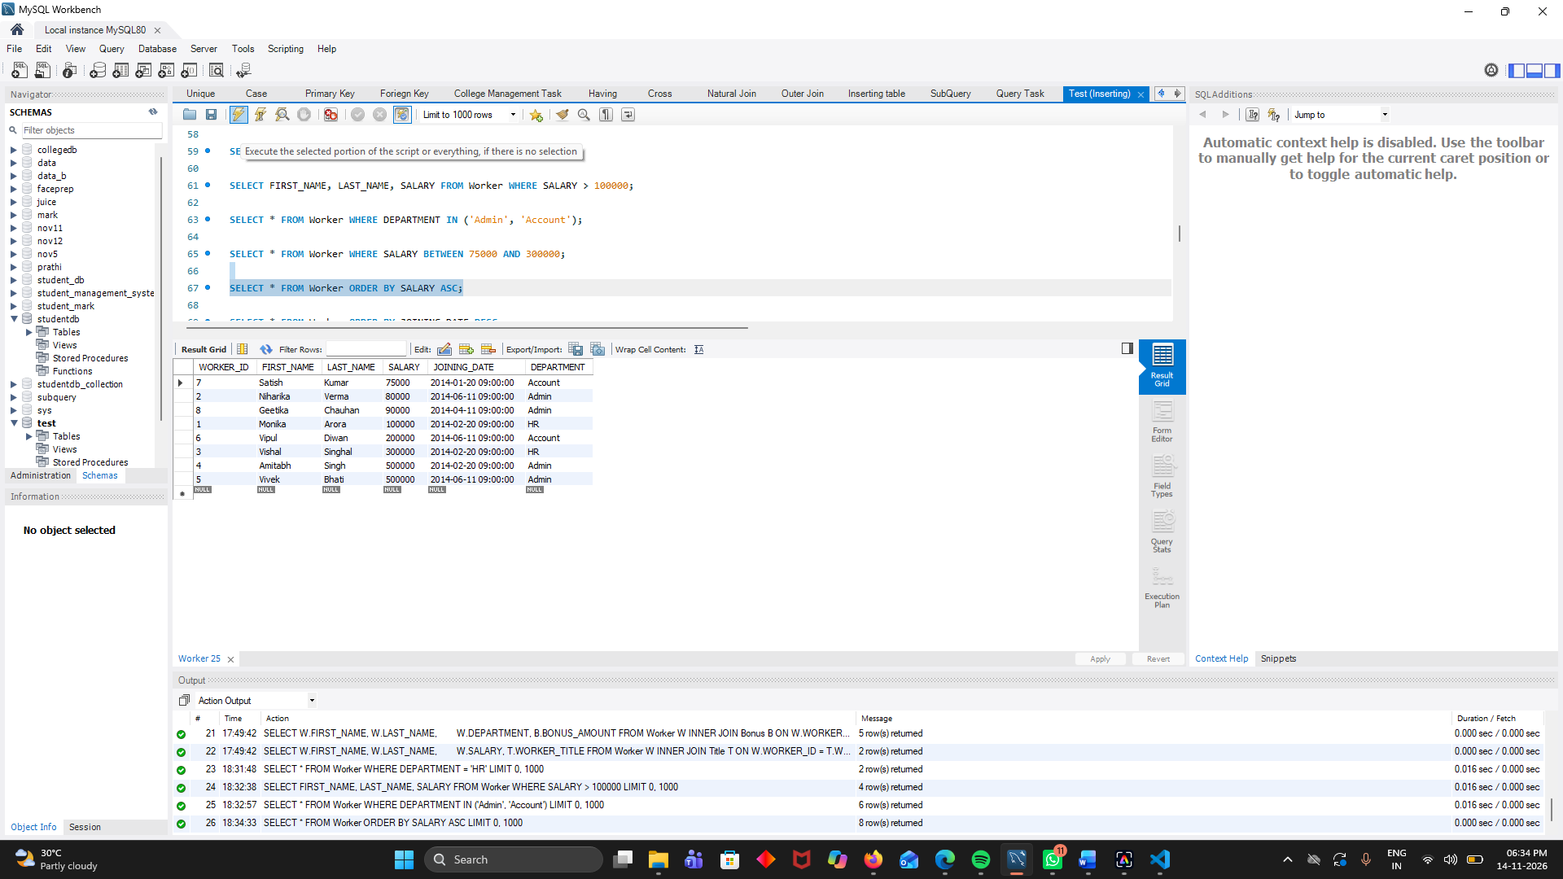

6. Write an SQL query to display employee details in descending order of their joining date.
SELECT * FROM Worker ORDER BY JOINING_DATE DESC;
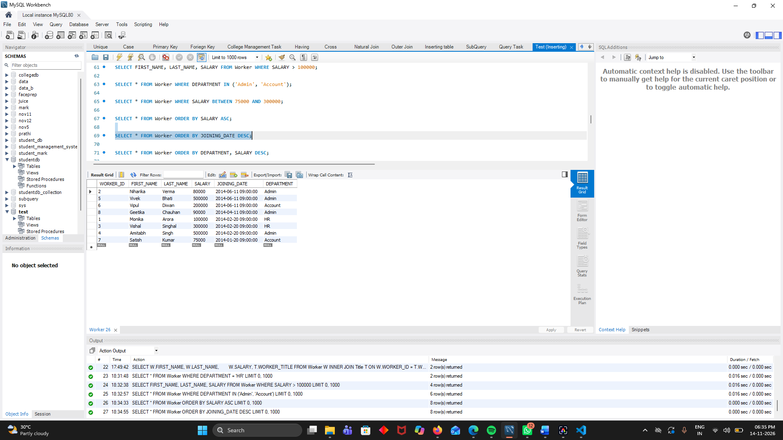
7. Write an SQL query to display employees in ascending order of department and descending order of salary.
SELECT * FROM Worker ORDER BY DEPARTMENT, SALARY DESC;
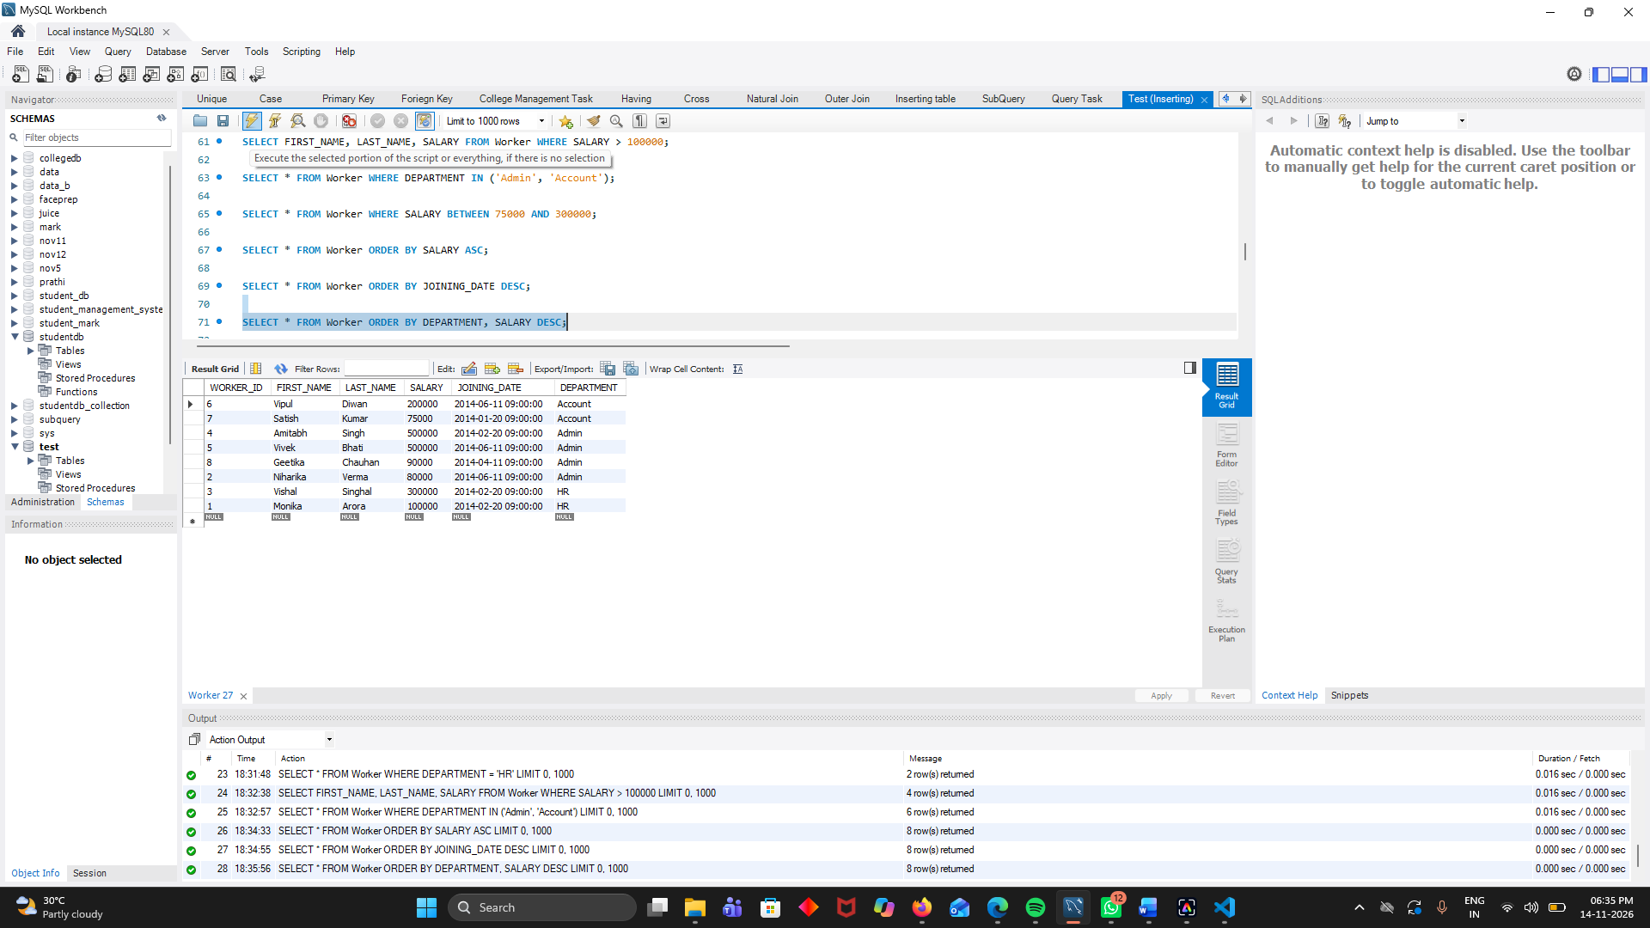

8. Write an SQL query to find the total number of employees in each department.
SELECT DEPARTMENT, COUNT(*) AS TOTAL_EMPLOYEES FROM Worker GROUP BY DEPARTMENT;
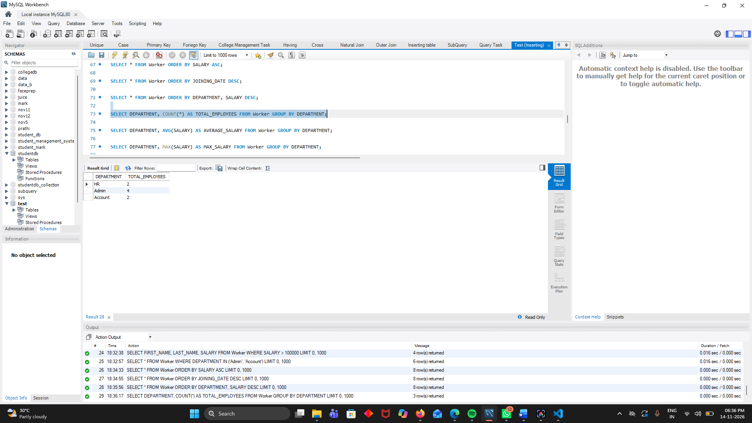
9. Write an SQL query to find the average salary of employees in each department.
SELECT DEPARTMENT, AVG(SALARY) AS AVERAGE_SALARY FROM Worker GROUP BY DEPARTMENT;
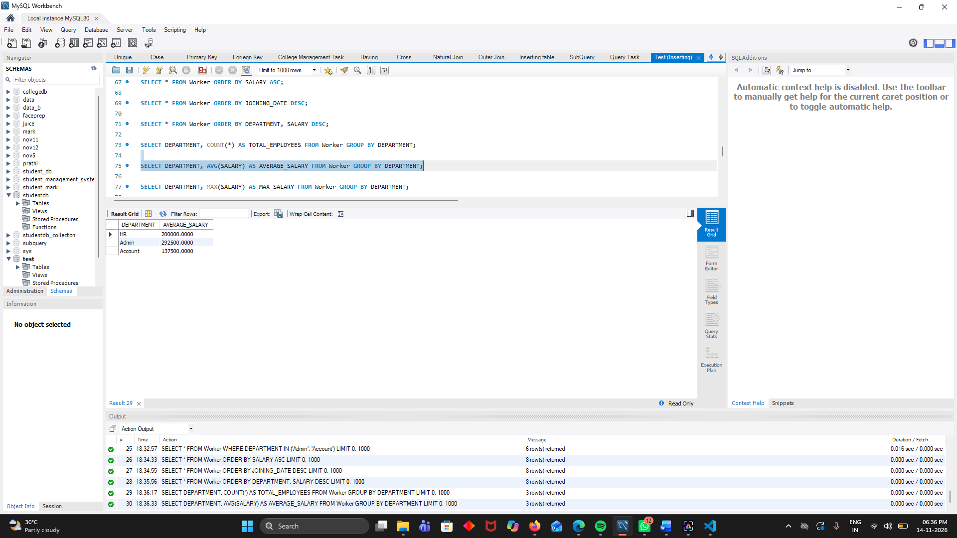
10. Write an SQL query to find the maximum salary in each department.
SELECT DEPARTMENT, MAX(SALARY) AS MAX_SALARY FROM Worker GROUP BY DEPARTMENT;
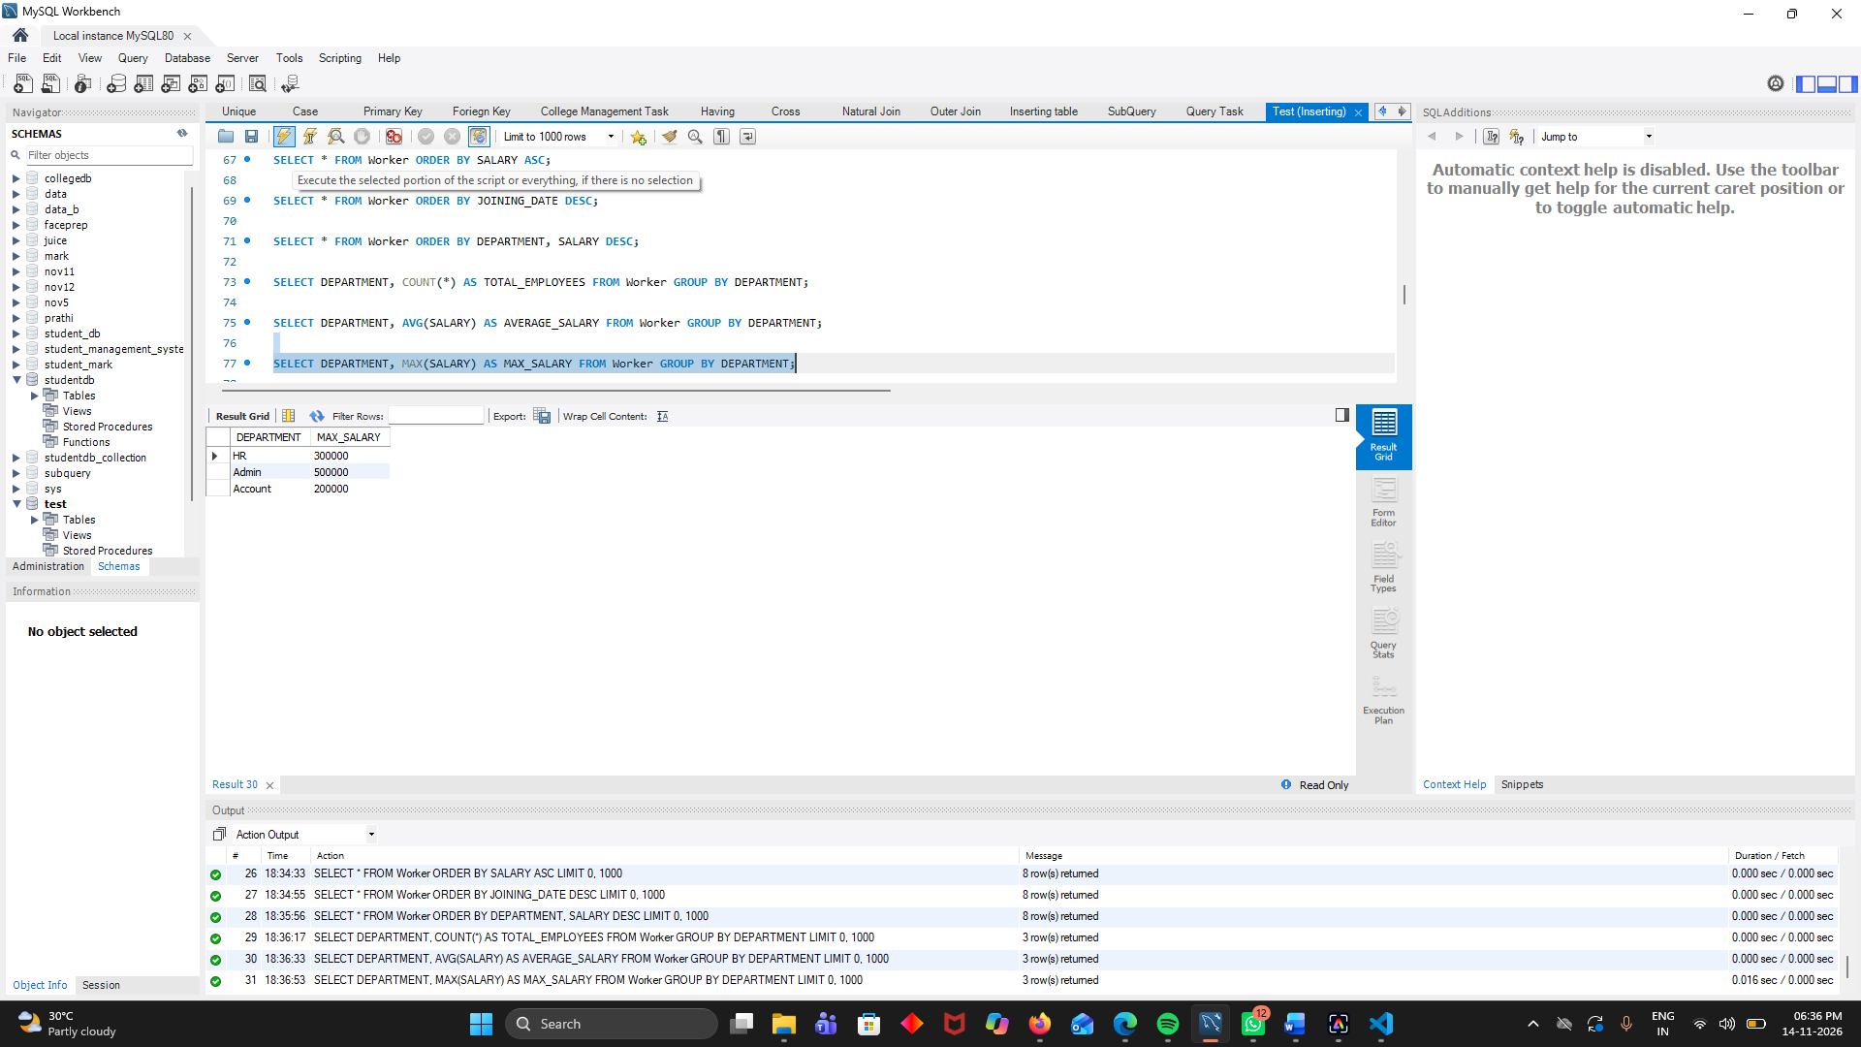

11. Write an SQL query to display departments having more than 2 employees using the HAVING clause.
SELECT DEPARTMENT, COUNT(*) AS TOTAL_EMPLOYEES FROM Worker GROUP BY DEPARTMENT HAVING COUNT(*) > 2;
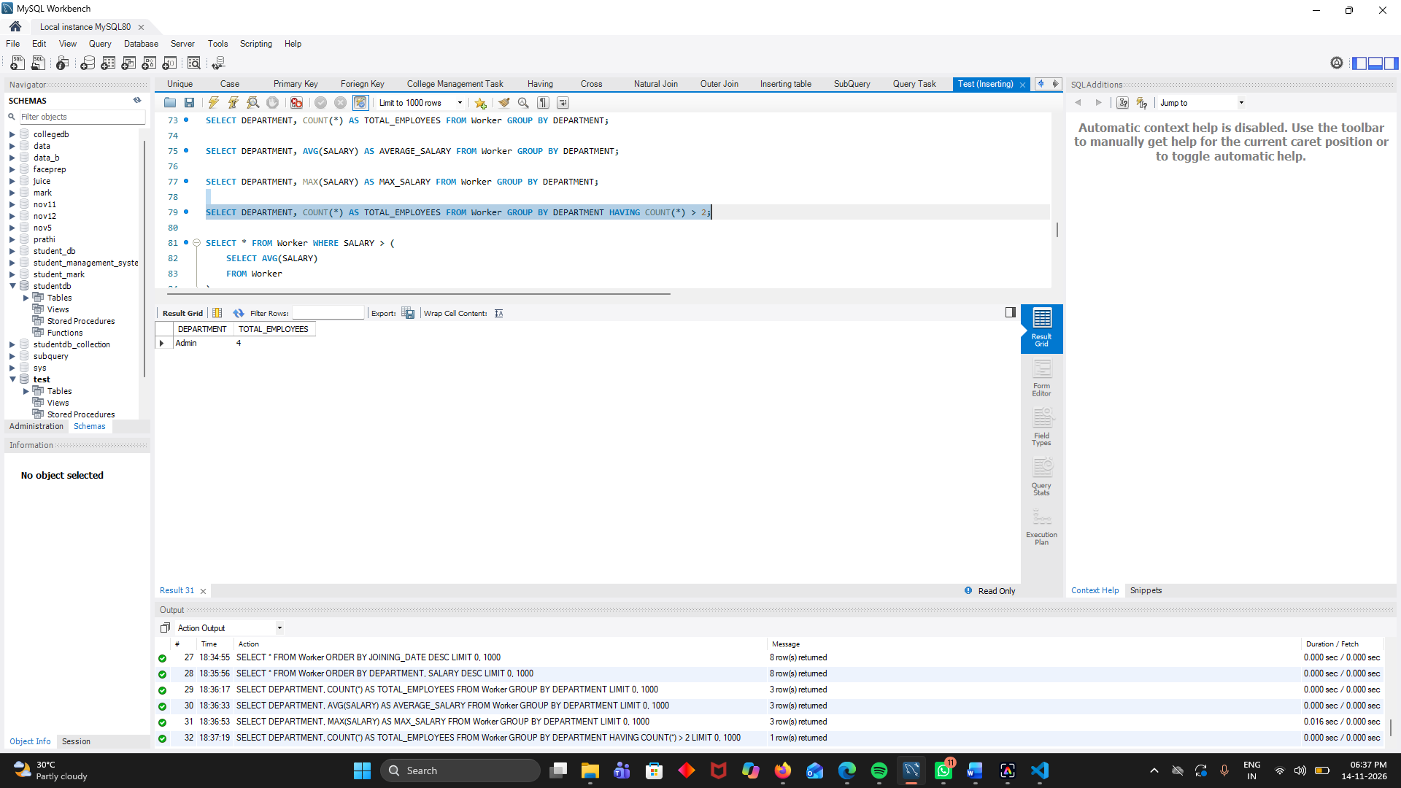

12. Write an SQL query to display employees whose salary is greater than the average salary of all employees.
SELECT * FROM Worker WHERE SALARY > (
SELECT AVG(SALARY)
FROM Worker
);
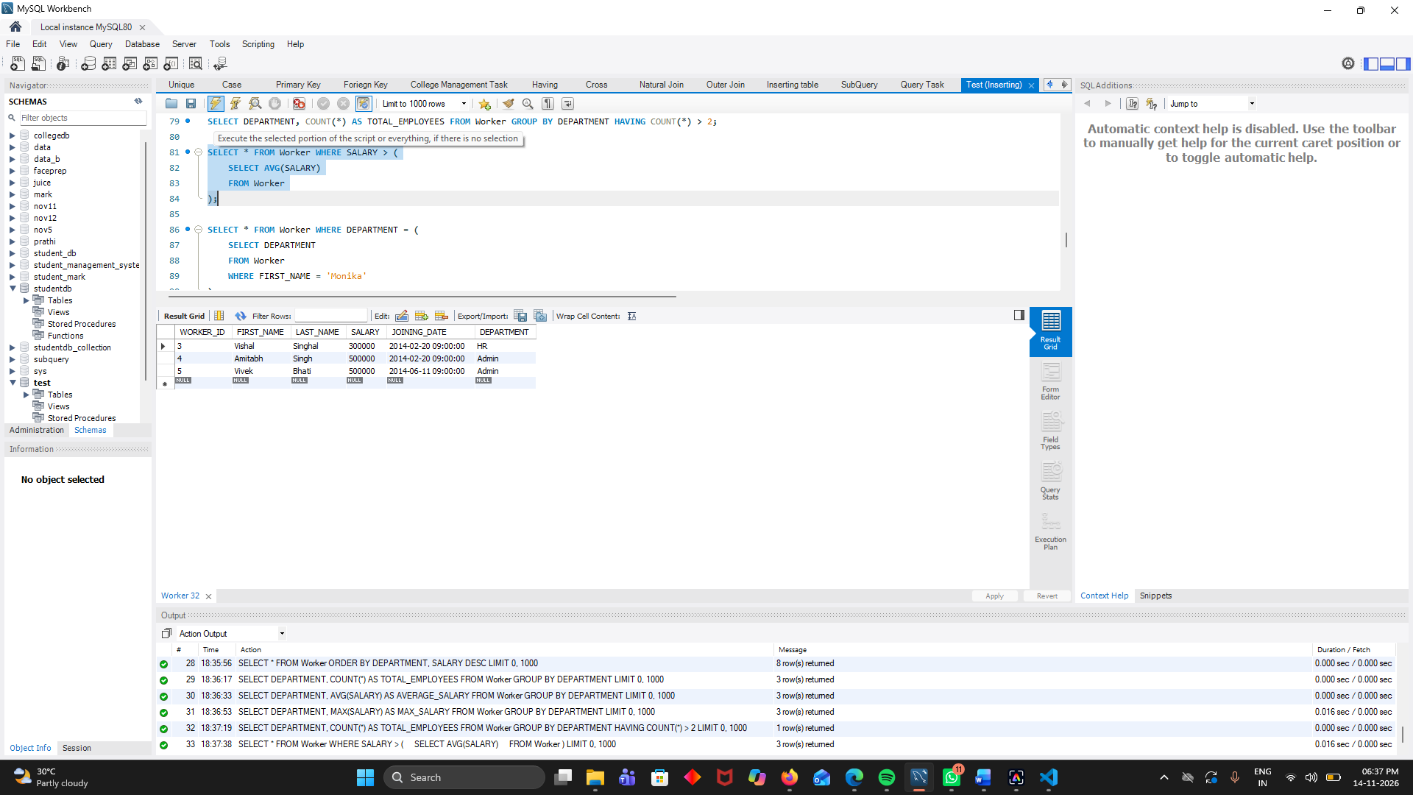

13. Write an SQL query to display employees who belong to the same department as Monika.

SELECT * FROM Worker WHERE DEPARTMENT = (
SELECT DEPARTMENT
FROM Worker
WHERE FIRST_NAME = 'Monika'
);
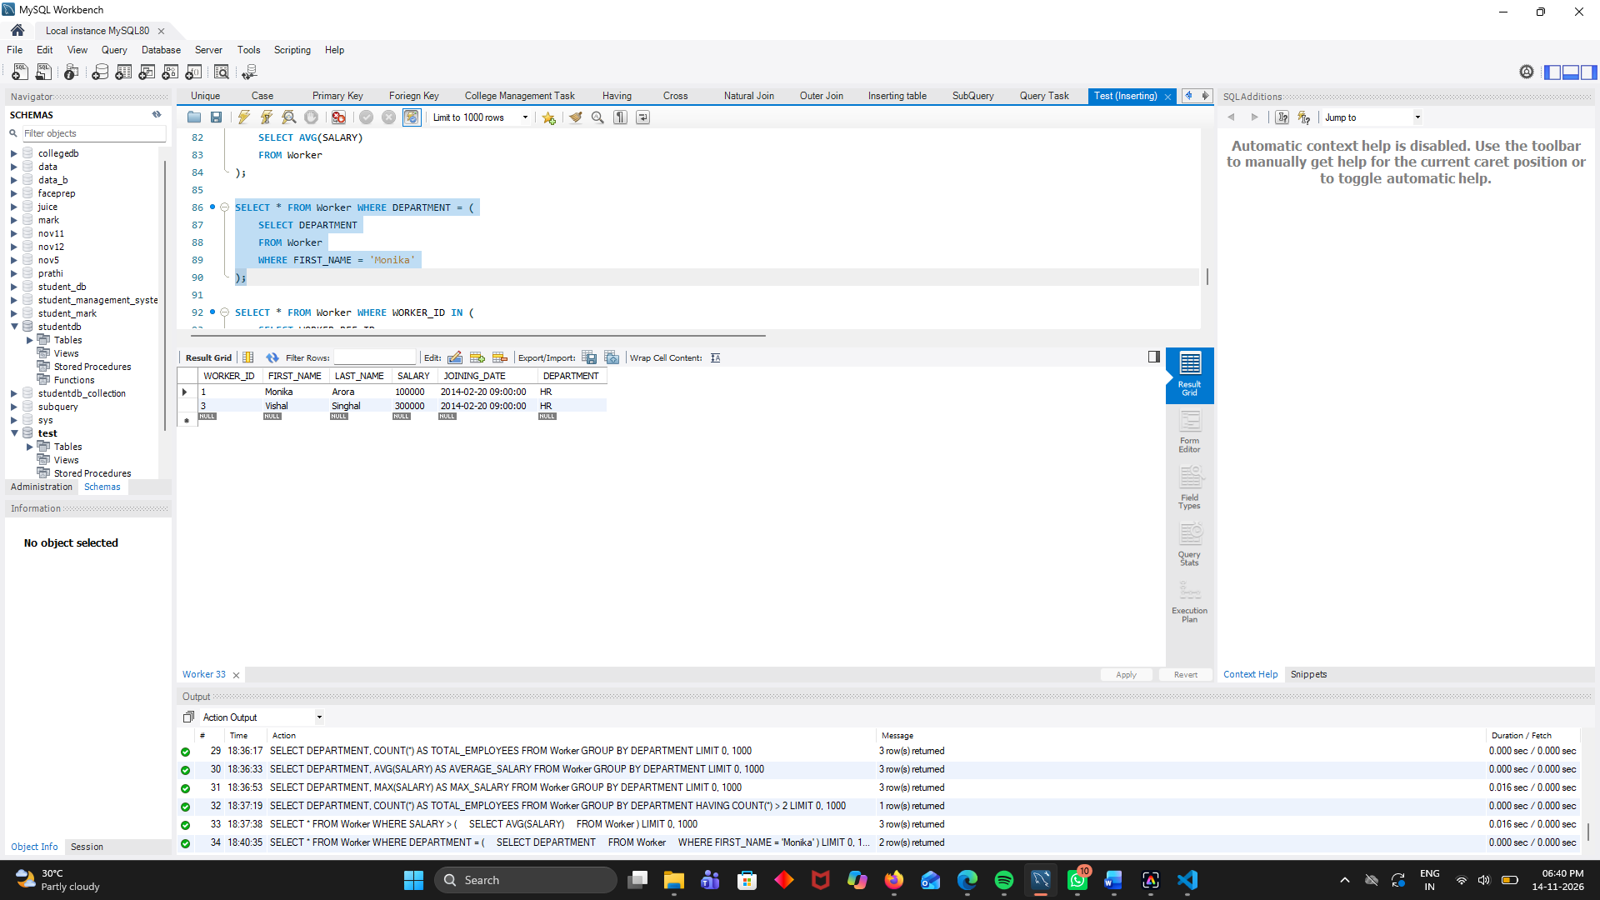

14. Write an SQL query to display employees who have received a bonus using a subquery.
SELECT * FROM Worker WHERE WORKER_ID IN (
SELECT WORKER_REF_ID
FROM Bonus
);
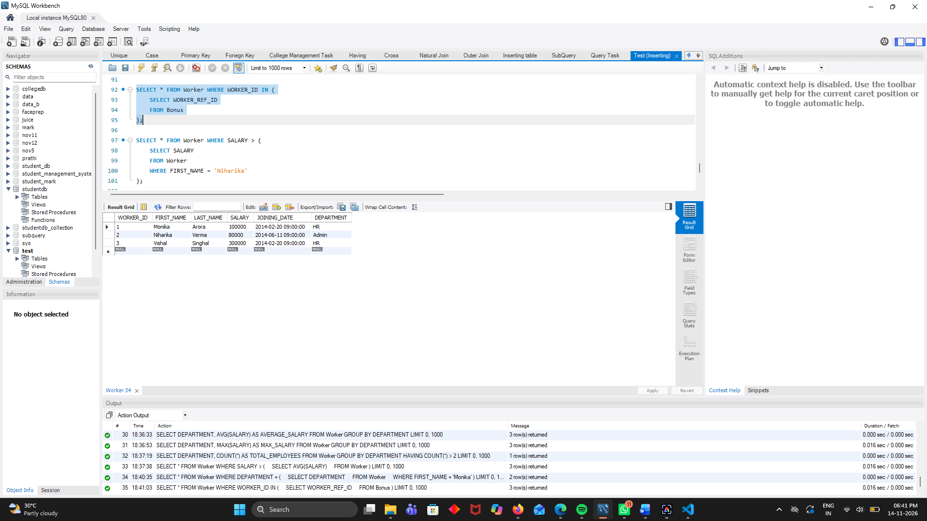
15. Write an SQL query to display employees whose salary is greater than the salary of Niharika.
SELECT * FROM Worker WHERE SALARY > (
SELECT SALARY
FROM Worker
WHERE FIRST_NAME = 'Niharika'
);
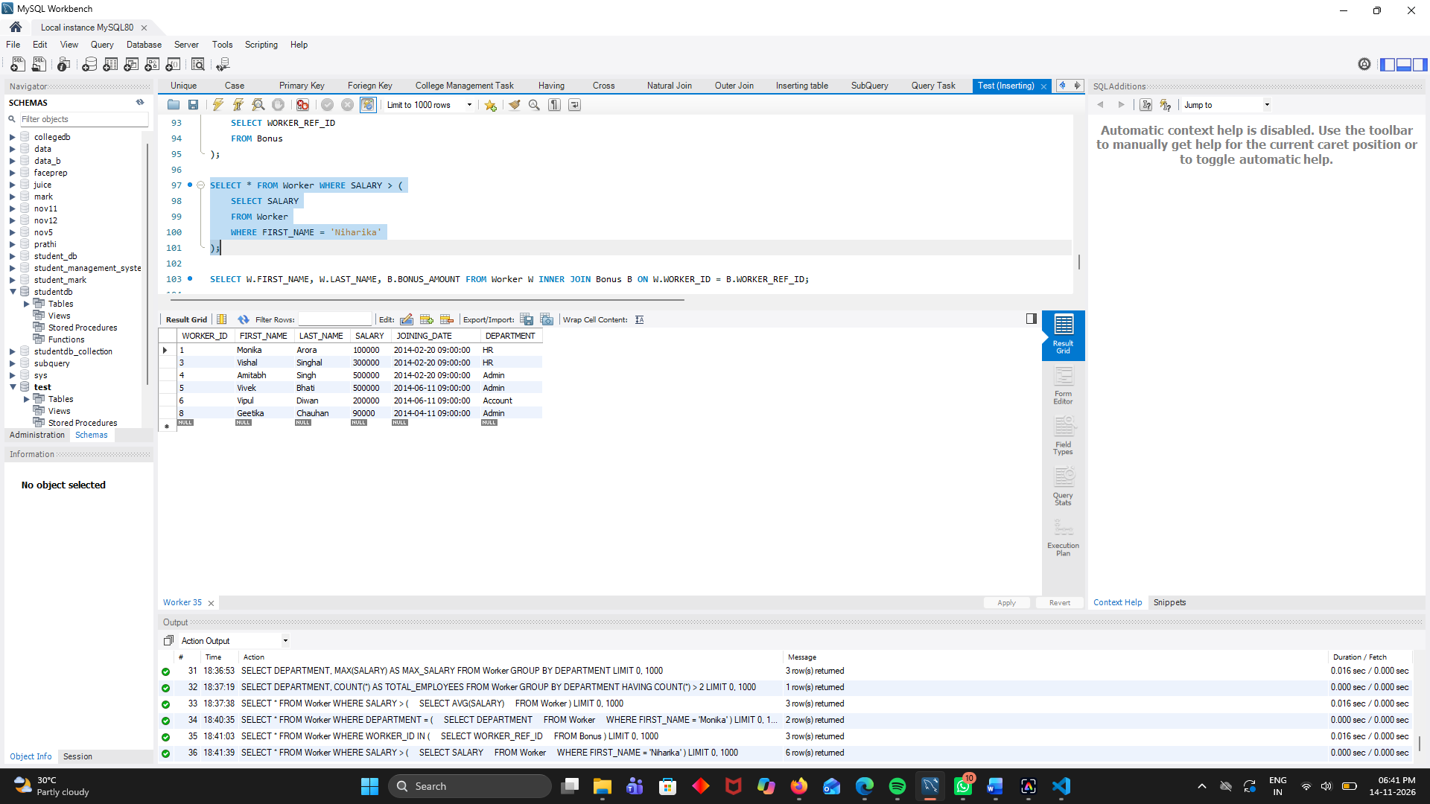

16. Write an SQL query using INNER JOIN to display employee first name, last name, and their bonus amount.
SELECT W.FIRST_NAME, W.LAST_NAME, B.BONUS_AMOUNT FROM Worker W INNER JOIN Bonus B ON W.WORKER_ID = B.WORKER_REF_ID;
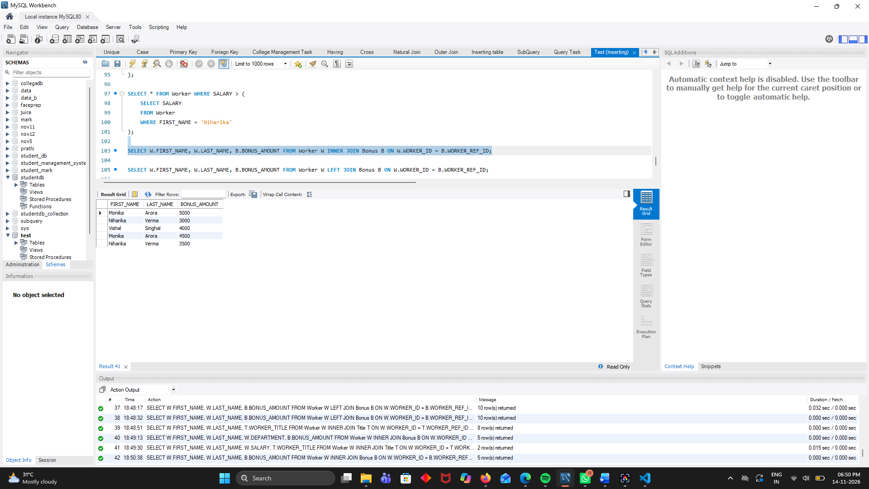

17. Write an SQL query using LEFT JOIN to display all employees along with their bonus amounts, including employees who have not received any bonus.
SELECT W.FIRST_NAME, W.LAST_NAME, B.BONUS_AMOUNT FROM Worker W LEFT JOIN Bonus B ON W.WORKER_ID = B.WORKER_REF_ID;
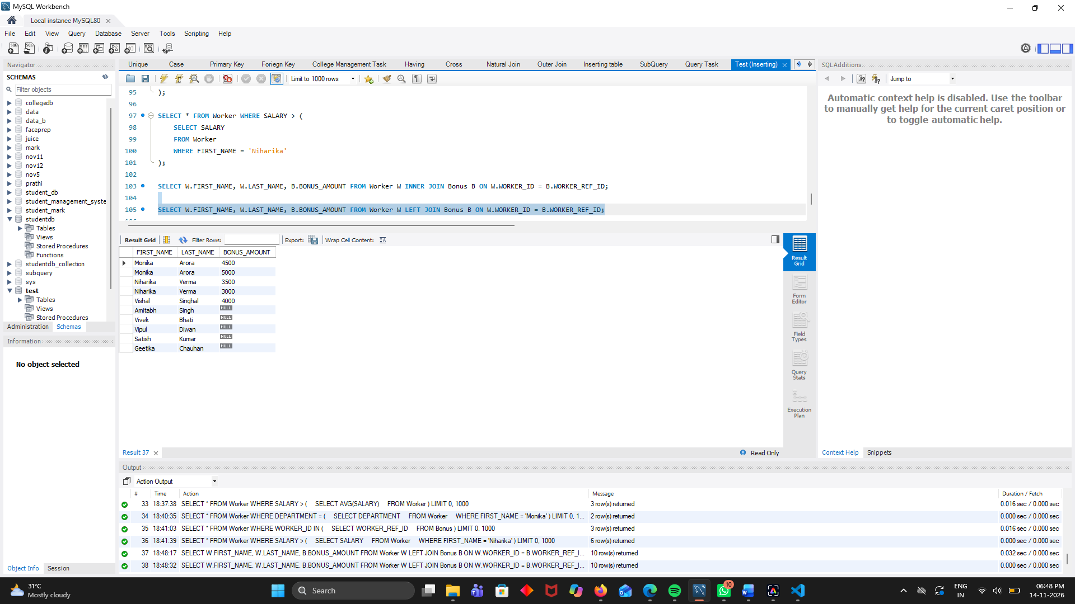

18. Write an SQL query using INNER JOIN to display employee names and their respective job titles.
SELECT W.FIRST_NAME, W.LAST_NAME, T.WORKER_TITLE FROM Worker W INNER JOIN Title T ON W.WORKER_ID = T.WORKER_REF_ID;
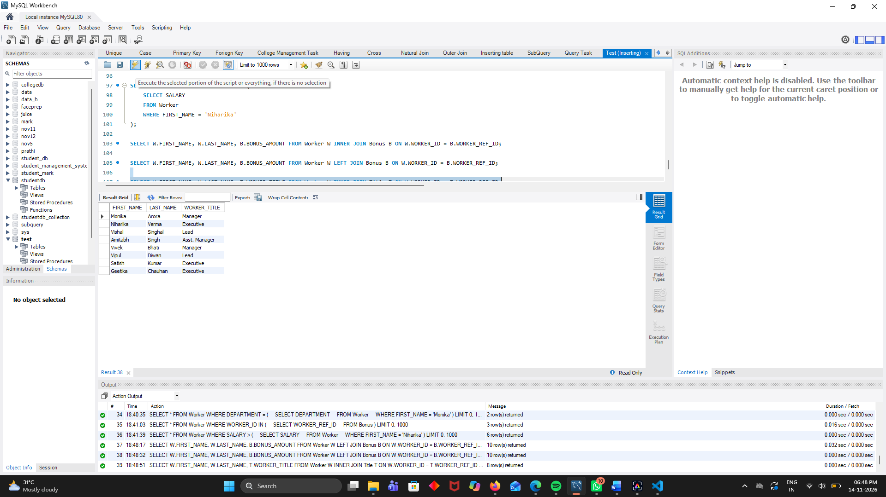

19. Write an SQL query using JOIN to display employee names, departments, and bonus amounts for employees who have received bonuses.
SELECT W.FIRST_NAME, W.LAST_NAME, W.DEPARTMENT, B.BONUS_AMOUNT FROM Worker W INNER JOIN Bonus B ON W.WORKER_ID = B.WORKER_REF_ID;
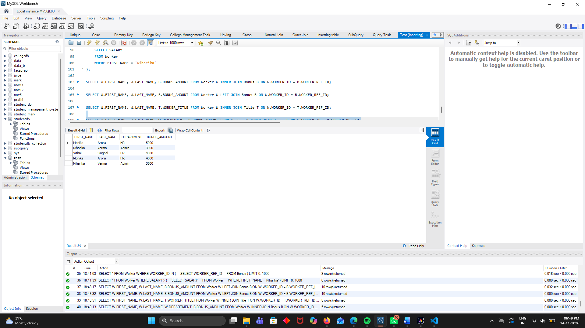

20. Write an SQL query using JOIN to display employee names, salaries, and job titles of employees whose job title is Manager.
SELECT W.FIRST_NAME, W.LAST_NAME, W.SALARY, T.WORKER_TITLE FROM Worker W INNER JOIN Title T ON W.WORKER_ID = T.WORKER_REF_ID WHERE T.WORKER_TITLE = 'Manager';


